
HEALTH, SAFETY & ENVIRONMENT MANAGEMENT SYSTEM
DAN Construction Safety Manual (DCSM)
Scaffolding

Document Control
Document No. | 01-000001-000000-DAN-HSE-PRC-000025 | Revision | R01
Issue Date | June 2026 | Classification | Controlled — Internal
Document Owner | HSE Department | Page Format | US Letter

Table of Contents

1. Purpose
2. Scope
3. References
4. Definitions
5. Deliverables
6. Project Scaffold Plan
7. General — Components
7.1 Tubing and Fittings Specifications
7.2 Platform Units (Planks)
8. Requirements Common to All Scaffolds
8.1 Foundations
9. Platform Construction and Use
9.1 Stability
9.2 Clearances from Power Lines
9.3 Gin Wheels, High Winds and Tools
10. System and Tube-and-Coupler Scaffolds
10.1 Horizontal and Vertical Members
10.2 System Scaffolds
10.3 Tube-and-Coupler Scaffolds
10.4 Light-Duty Tube-and-Coupler Scaffolds
10.5 Medium-Duty Tube-and-Coupler Scaffolds
11. Mobile and Tower Scaffolds
12. Other Scaffold Types
12.1 Fabricated Tubular Frame Scaffolds
12.2 Bracket Scaffolds
12.3 Underhung Scaffolds
13. Capacity
14. Access
15. Erection, Dismantling and Use
15.1 Distance from Power Lines (Use)
15.2 Welding on Scaffolds
16. Guardrail System and Fall Protection
17. Inspection and Tagging
18. Training
19. Documentation / Records
20. Related Documents
Revision History

1. Purpose
This document provides DAN general requirements and identifies the minimum technical and administrative safety requirements for scaffolding, including but not limited to personnel access, fixed platform heights, erection, supervision, inspection, use, tagging, alteration and dismantling.
Note: Scaffolding used for shoring of concrete formwork is covered in the Concrete and Masonry Construction chapter.

2. Scope
This document applies to the design, erection, use, inspection, tagging, alteration and dismantling of all scaffolds on DAN projects — supported, suspension, mobile/tower, fabricated tubular frame, bracket and underhung scaffolds.

3. References
- ANSI/ASSE A10.8 — Safety Requirements for Scaffolding; 29 CFR 1926 Subpart L (OSHA)
- EN 39 / EN 10219 (tubing); EN 74 (couplers); ASTM A500 / A123; BS 1139
- DCSM — Fall Protection and Prevention — Working at Height; DCSM — Walking / Working Surfaces; DCSM — Ladders
- DCSM — Electrical Safety; DCSM — Hot Works — Welding, Cutting and Brazing; DCSM — Concrete and Masonry Construction

4. Definitions
Term | Definition
Competent Person | A person trained to identify hazards and authorised to take prompt corrective measures; for scaffolds, qualified in erecting, moving, dismantling or altering scaffolds.
Qualified Person | A person who, by training and experience, is able to design scaffolds in accordance with the applicable standards.
Standard / Post | The vertical (upright) member of a scaffold.
Ledger / Runner | The horizontal longitudinal member; the Bearer / Transom is the horizontal transverse member.
Special Scaffold | A scaffold that exceeds the prescriptive limits of this document and must be specifically designed and reviewed.
Embossed Tubing | Scaffold tubing manufactured and permanently stamped to confirm it meets the specified yield stress.

5. Deliverables
- Project Scaffold Plan
- Permits (as required)
- Scaffold Register (Log)
Note: Any scaffold over 32 ft (10 m) requires a "Working at Height Permit". Any scaffold ≥ 115 ft (35 m) must be designed by a Competent Designer and verified by a DAN-approved third-party Competent Design Company.

6. Project Scaffold Plan
- A Competent Scaffold Supervisor and crew, certified by a DAN-approved third-party company, shall be assigned; the SH&E Representative leads development of the Project Scaffold Plan and the Project Manager facilitates implementation, review and approval.
- The plan designates a Qualified Person to design scaffolds and a Competent Person to supervise construction, perform inspections, maintain scaffold tags and conduct training.
- The plan shall include site-specific provisions for scaffold design, fall protection, means of access, safe use by other work crews, qualified/competent persons, the related AHA, and a summary of the tagging system.
- A Qualified Person shall design scaffolds per local/international standards; scaffolds shall be constructed and loaded in accordance with that design. Design requirements cover supported, suspension, float (ship), interior-hung, needle-beam, multilevel-suspended, mobile and scaffold-planking types.
- A Competent Person qualified in erecting, moving, dismantling or altering scaffolds shall supervise and direct the work and select only experienced, trained personnel.
Note: The use of Shore and Lean-To scaffolds is strictly PROHIBITED.

7. General — Components
- Components shall be inspected before each use, conform to this document, and be free from harmful corrosion; components from different manufacturers shall not be intermixed unless compatible (fit without mechanical force) and shall not be modified to intermix them.
- Obviously damaged, excessively corroded or defective components shall be marked with bright fluorescent orange paint and removed from site; defective couplers shall be destroyed (defective plank/tube sections may be cut off and the remainder reused).
- Dissimilar metals shall not be used together (e.g. aluminium ladders on steel-tube scaffolds); components shall not be exposed to acids/corrosives without protection and shall be properly stored to prevent damage.
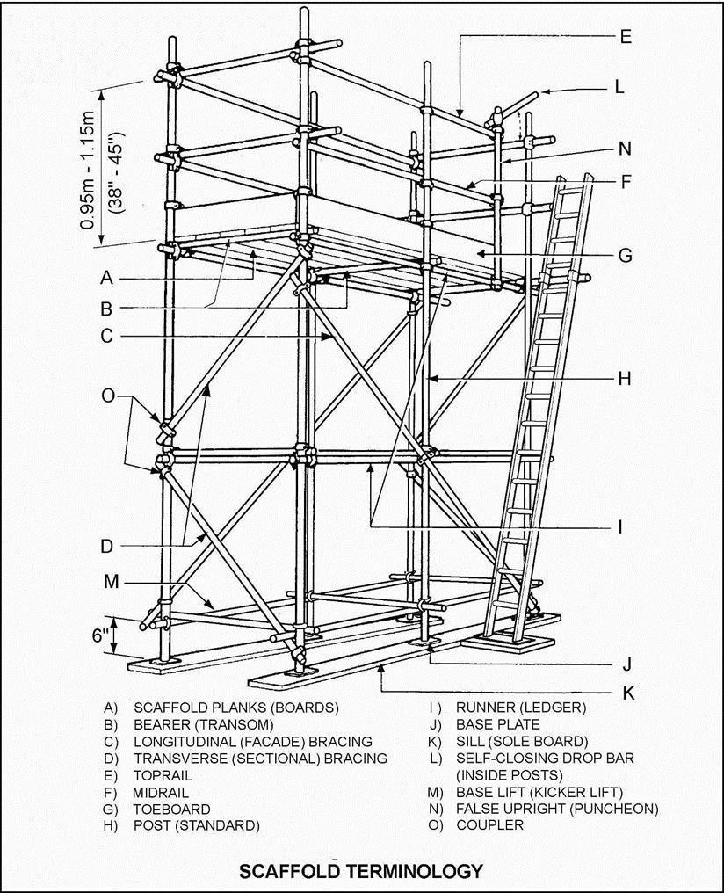
Figure 25-1 Scaffold Terminology

7.1 Tubing and Fittings Specifications
- Scaffold tubing shall be 1.9 in (4.8 cm) nominal outside diameter, welded or seamless structural steel suitable for hot-dip galvanising, fabricated to ASTM A500 Grade B (42 ksi min. yield), EN 39 type 4 (34 ksi, 4.0 mm wall — BS 1139 equivalent acceptable) or EN 10219 (46 ksi, 3.2 mm wall).
- Tubing shall meet ASTM A500 or EN 10021 testing/inspection (including the flattening test for welded tubing) with elongation after fracture not less than 20%; all test reports shall be in English and made available to DAN on request.
- Tube-and-coupler steel tubing shall be hot-dip galvanised (not painted) to ASTM A123 or EN 10240 (coating quality B.2); system and fabricated tubular-frame tubing may be painted.
- Couplers shall be marked as conforming to EN 74 (pressed or drop-forged); threaded parts shall attain full thread engagement and be lubricated regularly; girder couplers shall be used in pairs clamped on opposite sides of the section.
- Individual couplers shall comply with their rated Safe Working Loads (SWL), verified from manufacturer literature and independent sample testing; applied gravity loads (unfactored) shall be less than 40% of the rated SWL (safety factor of four).
Note: EN 39 thickness type 3 tubing — although 3.2 mm wall — is NOT equivalent and its use is PROHIBITED within KSA (even if embossed), since its minimum yield stress is only 235 N/mm² and not the required 320 N/mm².
Coupler | Load type | EN 74 Class | Rated SWL
Right-angle (double / load-bearing) coupler | Slip along a tube | B | 9.4 kN (2,100 lb)
Adjustable (swivel) coupler | Slip along a tube | A / B | 5.3 kN (1,190 lb) / 9.4 kN (2,100 lb)
End-to-end (sleeve) coupler | Tension / bending | B | 3.0 kN (675 lb) / 0.59 kN·m (435 lb·ft)
Bearer (putlog / single) coupler | Axial pull-out | — | 0.53 kN (120 lb)
Joint pin | Tension | — | 0 kN (0 lb)
Note: The rated SWL shown is based on a slipping safety factor of only 1.6.
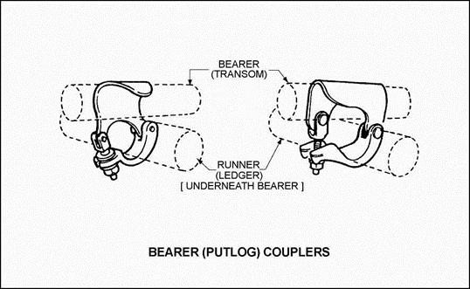
Figure 25-2 Bearer (Putlog) Couplers

7.2 Platform Units (Planks)
- Platform units shall be solid-sawn wood planks, Laminated Veneer Lumber (LVL) planks, fabricated planks or fabricated platforms, following all manufacturer/grading-agency recommendations; solid-sawn planks shall be "scaffold plank" grade, grade-stamped by a DAN-approved third party.
- LVL planks shall be at least 1.5 in (38 mm) thick × 9 in (225 mm) wide, permanently stamped with the product mark, certification body, "PROOF TESTED / SCAFFOLD PLANK / OSHA" and date of manufacture, with allowable spans per OSHA 1926.451 and ANSI/ASSE A10.8 (deflection not exceeding 1/60 of span), individually proof-tested and certified for exterior (wet-use) applications.
- Plank ends shall not be split more than 1 in (25 mm) without metal banding (never over 12 in / 300 mm); planks shall not be twisted or curled more than 1/2 in (13 mm), inspected before each use, and split/warped/decayed/damaged planks shall not be used.
- Planks shall not be painted/treated (except ends/edges), stood on end unattended, used as concrete forms / shoring / sills, and shall be stacked off the ground (layers tied/bonded above 20 planks).

8. Requirements Common to All Scaffolds
- All decking shall be secured to the frame, strength-tested and suitable for the intended load; manufacturer frames, bracing, pins and accessories shall not be interchanged.
- Direct connections and counterweights for adjustable suspension scaffolds shall resist at least four times the tipping moment at rated hoist load (or 1.5× at stall load, whichever is greater); suspension ropes (with hardware) shall support at least six times the maximum intended load.
- The stall load of any hoist shall not exceed three times its rated load; scaffolds and components shall not be loaded beyond their maximum intended load or rated capacity, whichever is less.

8.1 Foundations
- Foundations shall be sound, rigid and capable of carrying the scaffold's self-weight plus maximum intended load without settling; unstable objects (barrels, boxes, loose bricks/blocks) shall not be used as support.
- Sand or made-up ground may need compacting; bases such as floors/roofs may need shoring from underneath.
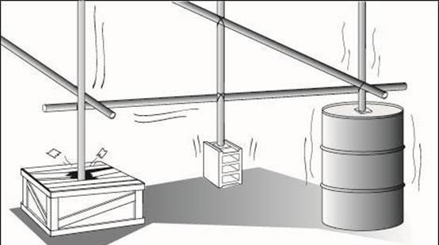
Figure 25-3 Unsafe Scaffold Foundation
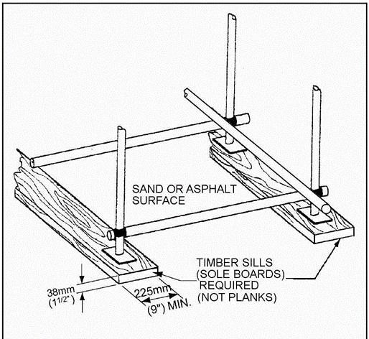
Figure 25-4 Scaffold Ground Support
- Timber sills (sole boards) at least 9 in (225 mm) wide × 1.5 in (38 mm) thick shall spread the load on sand, made-up ground, asphalt, wooden floors and soft/slippery or corrosive surfaces (scaffold planks shall not be used as sills); the ground beneath sills shall be level and compact.
- A sill shall extend under at least two posts where feasible; sills under individual posts shall be at least 30 in (765 mm) long; all posts shall be pitched on steel base plates at least 6 × 6 in (150 × 150 mm) × 1/4 in (6 mm) thick.
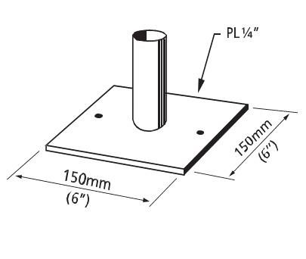
Figure 25-5 Typical Base Plate
- Screwjacks shall compensate for ground-level variation, adjusted to no more than 2/3 of the threaded length and loaded per the manufacturer; front-end loaders, forklifts or heavy equipment shall not support scaffolds.
- Scaffolds/planks shall not be hung from or supported by guardrails; cranes shall not lift any scaffold unless it is a specially designed, reviewed "special scaffold".

9. Platform Construction and Use
- Where the platform front edge is less than 14 in (360 mm) from the wall, guardrails are not required along that edge, but falling-object protection shall cover the gap; platforms shall be closed-planked as fully as possible between guardrails (except platforms being erected/dismantled).
- Maximum plank span: 5 ft (1.5 m) for 1.5 in (38 mm) thick planks and 8 ft (2.4 m) for 2 in (50 mm) thick planks (wet-use spans capped at 5 ft); planks shall be secured at both ends, extend 6–12 in (150–300 mm) beyond the bearer centreline, overlap only over supports (≥ 12 in / 300 mm) and never be nailed together.
- Gaps between platform units shall be less than 1 in (25 mm); 1–2 in gaps shall be covered with secured plywood strips, 2 in–2 ft gaps with ≥ 3/4 in (20 mm) exterior plywood overlapped each side, and gaps over 2 ft with secured cross planks.
- Platforms shall be kept free of obstructions and slippery substances, level, at least 27 in (675 mm / 3 planks) wide, and protected from welding slag/open flame; the next lift shall be fully installed and braced before moving platform units up.
- Safe landings shall be provided at the top of all ladders and at least every 30 ft (9 m) of ladder height (closed-planked and guardrail-protected); internal-ladder access openings shall be ≥ 27 in (675 mm) wide × 36 in (900 mm) deep with a self-closing drop bar or hinged trapdoor; portable ladders shall not be used on top of scaffold platforms.

9.1 Stability
- Posts and frames shall be erected plumb and vertically braced in both directions; uplift/tension locations shall be locked with pins (not joint pins), bolted/pinned spigots or sleeve couplers capable of carrying tension.
- Non-movable supported scaffolds taller than four times the minimum base dimension (4:1) shall be restrained from tipping by ties, outrigger frames or equivalent.
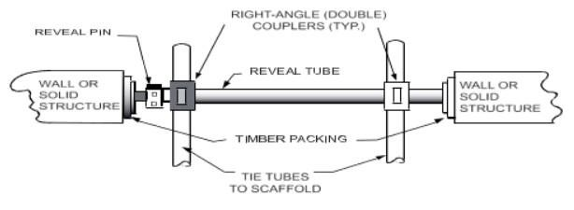
Figure 25-6 Plan Review of Reveal Tie
- Ties shall connect to load-capable structures via a tie tube on at least two posts/horizontals coupled with right-angle couplers, installed adjacent to transverse bracing; the lowest tie at the 4:1 lift, the uppermost as close as feasible to the top.
- Ties shall be spaced vertically every 26 ft (8 m / 4 lifts) or less and at both ends and ≤ 30 ft (9 m) horizontal intervals; reveal tubes shall be wedged with reveal pins and shall not exceed 50% of the total ties.
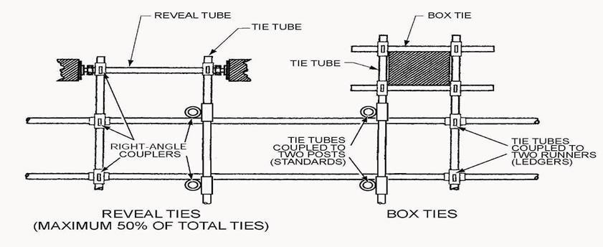
Figure 25-7 Scaffold Ties
- Outrigger frames shall extend the base to more than 1/4 of the scaffold height; rakers may be used only where ties/outriggers are impractical — each a single tube ≤ 21 ft (6.4 m), not spliced, at 65°–75° above horizontal.
- Only one lift may be installed above the raker tie-in (top coupled no higher than the third lift); the raker bottom shall be anchored against movement in all directions, with the bottom and midpoint tied back to at least two posts.
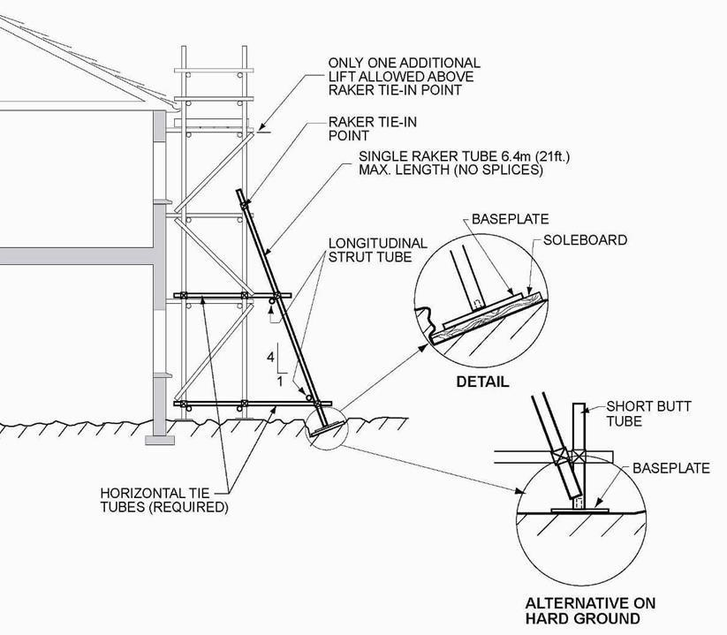
Figure 25-8 Raker
- Ties/outriggers shall prevent tipping wherever an eccentric load (e.g. cantilevered platform or external ladder) is applied; connections on each lift shall be fully tightened before the next lift is assembled.
- When dismantling, components above each tie shall be removed before the tie; scaffolds enclosed with tarps/sheeting shall be designed by a degreed structural engineer for the increased wind loading.

9.2 Clearances from Power Lines
Scaffold bases shall be at least 1.5 times the depth of an excavation from its edge. Scaffolds (and any conductive material on them) shall maintain the following clearances from energised power lines:
Line type / voltage | Minimum distance | Alternative
Insulated, < 300 V | 3 ft (1 m) | 2× insulator length, never < 10 ft (3 m)
Insulated, 300 V–50 kV | 10 ft (3 m) | —
Insulated, > 50 kV | 10 ft (3 m) + 0.4 in (10 mm) per kV over 50 kV | —
Un-insulated, < 50 kV | 10 ft (3 m) | 2× insulator length, never < 10 ft (3 m)
Un-insulated, > 50 kV | 10 ft (3 m) + 0.4 in (10 mm) per kV over 50 kV | —
Scaffold operations adjacent to overhead power lines are prohibited unless the line is de-energised (with positive LOTO to prevent re-energisation), relocated, or fitted with protective coverings (see the Electrical Safety chapter).

9.3 Gin Wheels, High Winds and Tools
- Gin wheels shall be mounted on a cantilever tube ≤ 30 in (750 mm) from the scaffold, fixed with right-angle couplers to two posts; a ring-type wheel is preferred (hook type lashed and moused); loads shall not exceed 110 lb (50 kg) on a correctly sized rope (usually 3/4 in / 18 mm).
- Personnel shall not be on any scaffold during storms or sustained winds over 40 mph (65 kph), or during thunderstorms/lightning; scaffolds shall be re-inspected by the Scaffold Supervisor after high winds.
- Only tools recommended by the scaffold manufacturer shall be used during erection and dismantling.

10. System and Tube-and-Coupler Scaffolds

10.1 Horizontal and Vertical Members
- Every line of posts shall have continuous runners (longitudinal) and bearers (transverse) at each lift; no lift height shall exceed 6.5 ft (2 m); board bearers shall limit plank spans and be installed on top of (not under) supporting runners.
- Trusses/ladder beams shall be horizontally braced at top and bottom chords (e.g. at quarter points) to prevent lateral-torsional buckling.
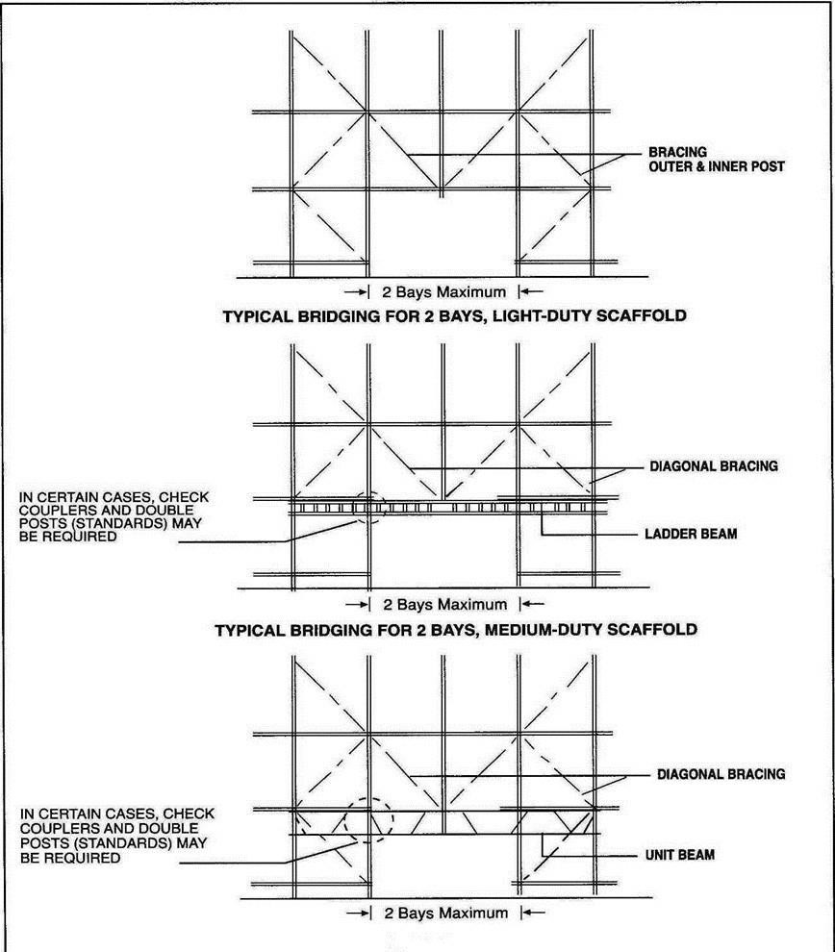
Figure 25-9 Typical Bridging
- Vertical bracing shall be installed at 35°–55° above horizontal in both directions for the full height; transverse braces shall connect within 12 in (300 mm) of the bearer/post node, longitudinal braces within 12 in of the runner/post node.
- Brace ends may be joined with sleeve couplers (not joint pins); braces under large tension shall overlap ≥ 12 in (300 mm) and be joined with at least two swivel couplers.
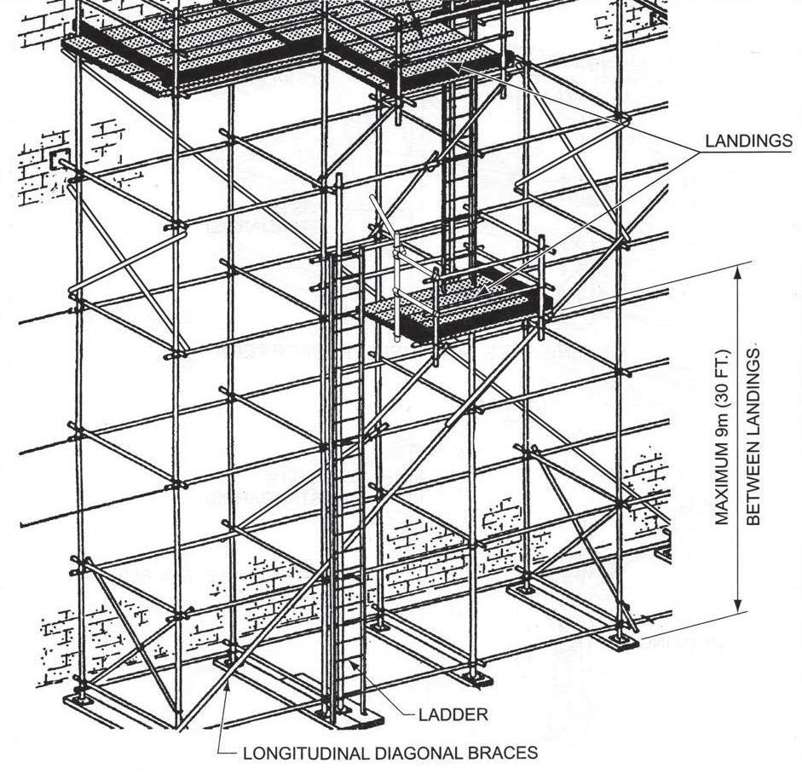
Figure 25-10 Landing
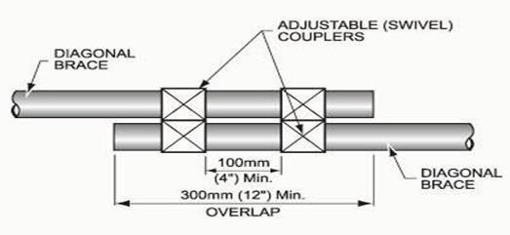
Figure 25-11 Brace Splice

10.2 System Scaffolds
- System scaffolding shall be built in full compliance with the manufacturer's grid-size information; systems from different manufacturers shall not be intermixed (nor mixed with tube-and-coupler except as bracing) without written permission.
- Outdoor system scaffolds shall be vertically braced in both directions (35°–55°) to full height for each 33 ft (10 m) of run; connections shall be tightened with a single hammer blow to the wedge/cup; posts shall be connected by bolted spigots (two spigot pins where uplift may occur).
Note: The locking-pin type of system scaffolding shall NOT be used.
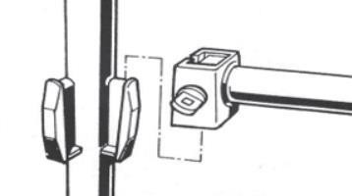
Figure 25-12 PROHIBITED Locking-Pin Type System Scaffold

10.3 Tube-and-Coupler Scaffolds
- Joints in posts shall be staggered (not in the same lift on adjacent posts), using joint pins (compression only) or — where uplift can occur — properly tightened sleeve couplers.
- Runners and bearers shall be attached to the inside of each post with right-angle (load-bearing) couplers; bearer couplers shall rest directly on the runner couplers; at planked lifts, bearer (putlog) couplers (not right-angle) shall attach bearers to runners.
- Bearers shall extend at least 4 in (100 mm) beyond the runner centreline; the base lift shall be ~6 in (150 mm) above the base; runners/bearers shall have no more than one (staggered) joint between adjacent posts.
- Right-angle (double) couplers shall be installed with the load against the hinge flap, not the bolt; couplers shall be tightened to the manufacturer's torque (preferably 40–80 N·m / 30–60 ft·lb) using only proper scaffold spanners — "cheater bars" are prohibited.
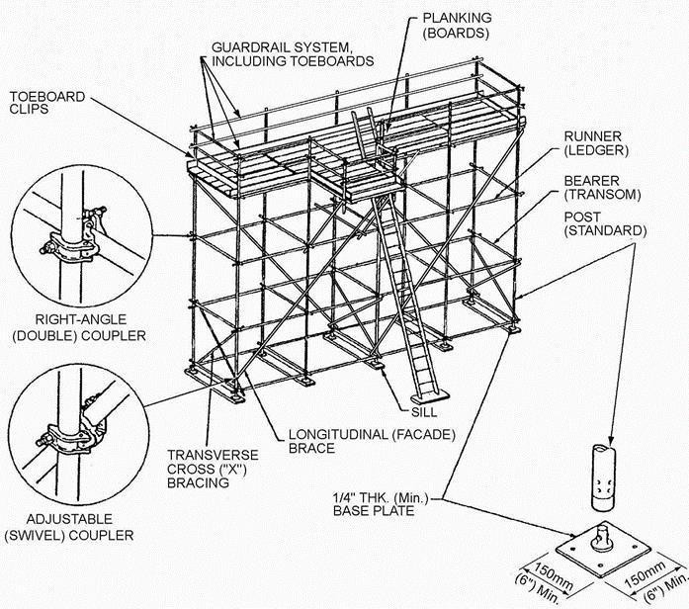
Figure 25-13 Typical Tube-and-Coupler Scaffold
Vertical bracing for tube-and-coupler scaffolds may be transverse "zig-zag" or "X" bracing (at both ends and at least every third line of posts, no more than three adjacent bays open) and longitudinal (façade) bracing along the front and rear post lines (repeated at least every fifth post), all installed at 35°–55° above horizontal.

10.4 Light-Duty Tube-and-Coupler Scaffolds
For light-duty scaffolds built entirely of embossed (stamped) tubing, the permitted transverse post spacing (bearer span) and maximum longitudinal post spacing (runner span) are:
Embossed tubing | Planks per bay (9 in / 22.5 cm) | Transverse post spacing (bearer span) | Longitudinal post spacing (runner span)
Option 1 | 4 | 3.25 ft (1 m) | 9 ft (2.7 m) max.
Option 2 | 5 | 4 ft (1.2 m) | 8 ft (2.4 m) max.
For non-embossed tubing the spans are reduced as follows (based on 1.9 in / 48.3 mm O.D., 3.2 mm wall, Fy = 235 N/mm²):
Non-embossed tubing | Planks per bay (9 in / 22.5 cm) | Transverse post spacing (bearer span) | Longitudinal post spacing (runner span)
Option 1 | 4 | 3.25 ft (1 m) | 7.5 ft (2.3 m) max.
Option 2 | 5 | 4 ft (1.2 m) | 6 ft (1.8 m) max.
Light-duty scaffolds may have a maximum of three working levels in use at once, with the maximum planked levels and heights (at 25 lb/ft² / 1.2 kN/m² per level):
Working levels in use | Max. total planked levels | Maximum scaffold height
1 | 9 | 125 ft (38 m)
2 | 6 | 125 ft (38 m)
3 | 3 | 91 ft (28 m)
Scaffolds exceeding these limits shall be classified as "special scaffolds" and designed/reviewed; properly designed system scaffolding is preferred over tube-and-coupler for scaffolds over 125 ft (38 m).

10.5 Medium-Duty Tube-and-Coupler Scaffolds
- All tubing for medium-duty (and heavier) scaffolds shall be embossed; the maximum transverse post spacing is 4 ft (1.2 m) and maximum longitudinal post spacing 6 ft (1.83 m); at least one board bearer shall be installed in each bay of every planked level.
- Medium-duty scaffolds may have a maximum of two working levels in use at once (at 50 lb/ft² / 2.4 kN/m² per level):
Working levels in use | Max. total planked levels | Maximum scaffold height
1 | 7 | 125 ft (38 m)
2 | 2 | 78 ft (24 m)

11. Mobile and Tower Scaffolds
- Mobile/tower scaffolds shall be plumb, level, square and braced horizontally and vertically; plan (horizontal) bracing shall be installed at the base, top and every third lift to prevent racking.
- Single-bay light-duty mobile scaffolds shall use embossed tubing with maximum 6.5 ft (2 m) post spacing (medium-duty 5 ft / 1.5 m); screwjacks shall be used for levelling.
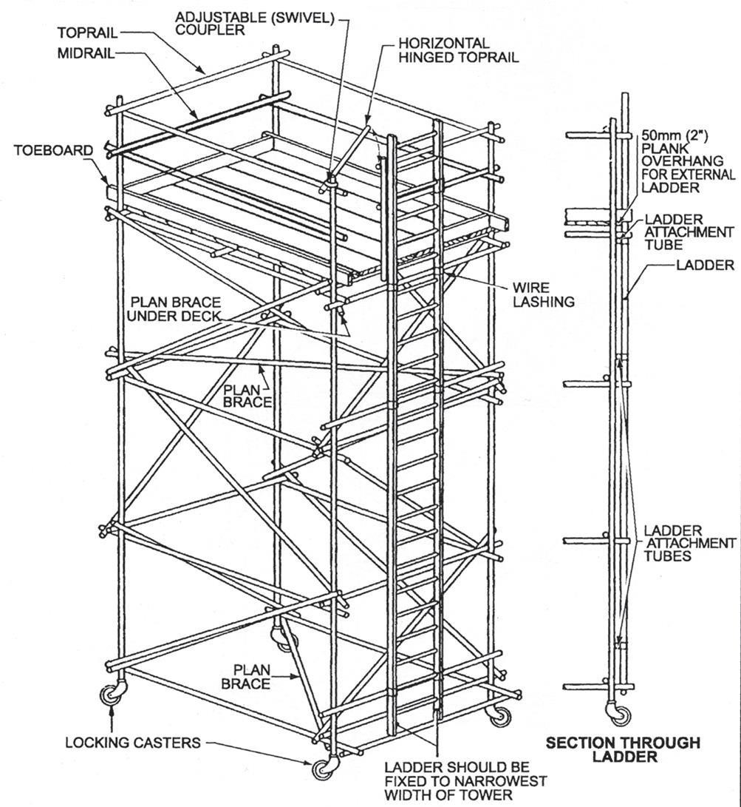
Figure 25-14 Mobile Scaffold (External Ladders)
- Light-duty casters shall be ≥ 5 in (13 cm) diameter and medium-duty ≥ 7 in (18 cm); casters shall have a positive (preferably latch-type) wheel lock and be secured to the post/screwjack by locking pins.
- Working areas shall not extend beyond the base (no cantilevers); the uppermost platform shall not exceed three times the minimum base dimension for mobile scaffolds (four times for freestanding towers); maximum mobile height is 40 ft (12.2 m), with a complete guardrail system at every platform.
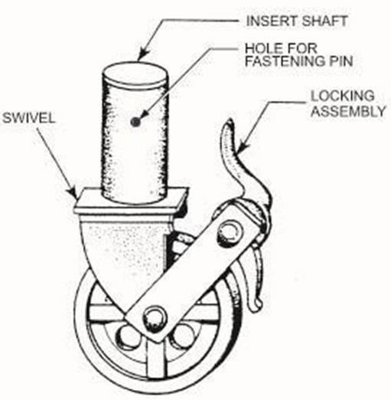
Figure 25-15 Mobile Scaffold Caster
- A mobile scaffold shall be used/moved only on firm, level surfaces, moved by pushing at the base (force applied no higher than 5 ft / 1.5 m), with no personnel, equipment or materials aboard while in motion and casters locked except during movement.

12. Other Scaffold Types

12.1 Fabricated Tubular Frame Scaffolds
- Erected per the manufacturer's instructions; limited to light-duty loading (25 lb/ft² / 1.2 kN/m²) and a maximum height of 20 ft (6 m); components from different manufacturers shall not be intermixed; flip-lock fittings shall secure horizontals/diagonals; scissor (cross) bracing on both sides in every bay between each lift; complete guardrail system with toeboards at every platform.

12.2 Bracket Scaffolds
- Brackets/straps erected per the manufacturer and limited to light-duty loading; bracket straps welded to tank walls shall be at least 10 in × 3 in × 3/8 in (250 × 75 × 10 mm) with specified fillet welds, welded and inspected by DAN-approved third-party certified personnel, and installed vertically.
- A continuous guardrail system shall run along the outside edge (and inside where the gap exceeds 14 in / 360 mm); working levels shall be fully planked (2–3 planks wide), planks overlapped ≥ 9 in (23 cm) and secured; the area below shall be barricaded with warning signs.

12.3 Underhung Scaffolds
- Constructed with galvanised system or tube-and-coupler scaffolding (rosette/captive-wedge systems require plan bracing or fully locked-in metal planks); hung from structures capable of safely supporting the loads, with a complete guardrail system and toeboards at all levels.
- Hanger tubes shall attach to the supporting beam by a box connection (two horizontal tubes on top and bottom flanges with girder couplers) — attaching girder couplers to only the bottom flange is prohibited; check (safety) couplers shall be installed at the top and bottom of all hanger tubes and beneath all trapeze tubes; only drop-forged girder couplers shall be used.
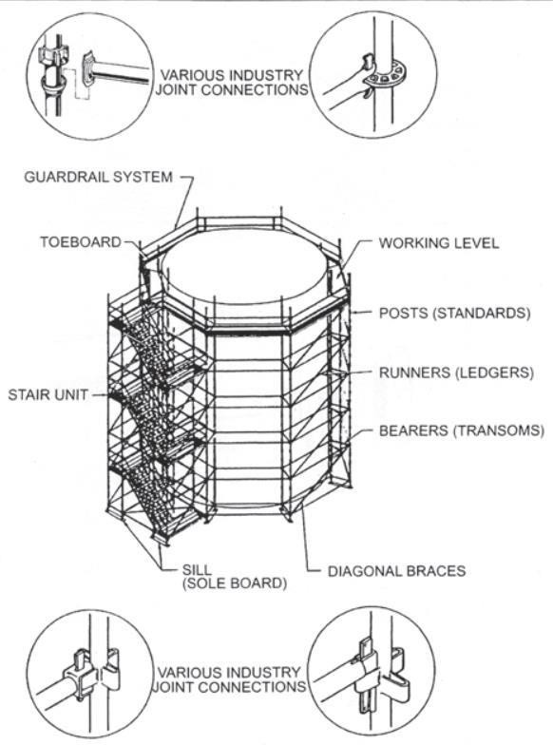
Figure 25-16 Typical System Scaffold
Note: Some figures in this chapter are reproduced with permission from A Guide to Practical Scaffolding, published by the Construction Industry Training Board (CITB).

13. Capacity
- Scaffolds and components shall support, without failure, their own weight plus at least four times the maximum intended load; damaged or weakened accessories shall be immediately repaired or replaced.
- Load-carrying timber members shall be a minimum of 1,500 fibre (stress-grade) construction-grade lumber; storage of materials/loads on the scaffold is PROHIBITED.

14. Access
- Where platforms are more than 12 in (30.5 cm) above/below the access point, use portable/hook-on/attachable ladders, stair towers, ramps, walkways or integral prefabricated access; maintain three-point contact and do not hand-carry tools while climbing; cross braces shall not be used as access.
- Hook-on/attachable ladders shall be positioned so the bottom rung is ≤ 12 in (30.5 cm) above the support level, have rest platforms at ≤ 35.1 ft (10.7 m) intervals, a minimum rung length of 11.4 in (29 cm) and maximum rung spacing of 16.7 in (42.5 cm).
- Stair towers shall have a stair rail (top and mid-rail) each side, treads/landings with slip-resistant surfaces, stairways at 40°–60° from horizontal, uniform riser height/tread depth within 0.24 in (0.6 cm), and at least 18 in (45.7 cm) width; ramps/walkways shall not exceed 1V:3H and shall have cleats if steeper than 1V:8H.
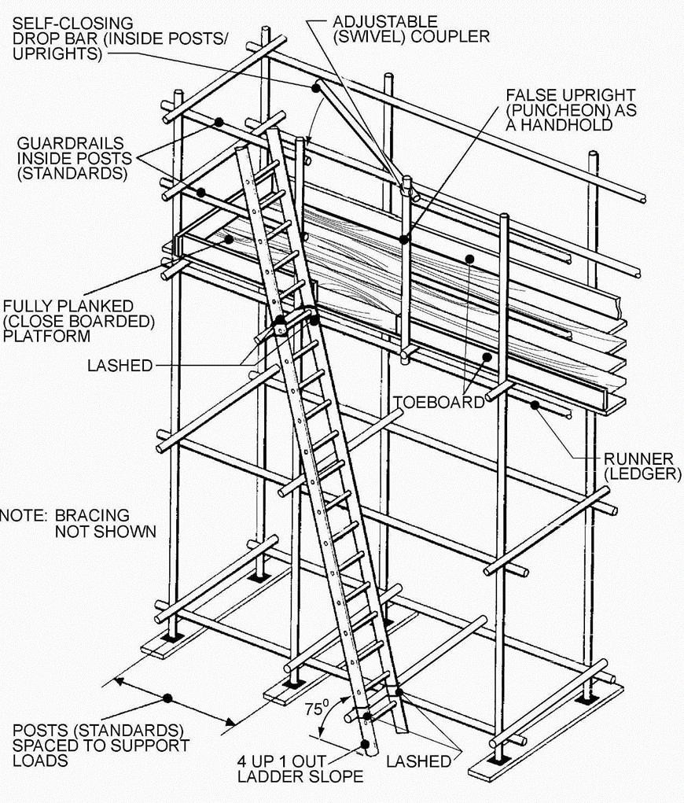
Figure 25-17 External Ladder Access

15. Erection, Dismantling and Use
- Personnel shall keep both hands free for handholds when moving on scaffolds, carry tools in pouches/belts, hoist/lower members by hand line (never thrown), and keep scaffolds clear of debris; scaffolds over 49.9 ft (15.2 m) shall be approved by the DAN Representative and a registered Professional Engineer.
- Adjusting screws shall be installed only between the base plate and frame (never with casters) and not extended more than 12 in (30.5 cm); cross/diagonal bracing shall keep the scaffold plumb, square and rigid with all connections secure.
- Scaffolds shall not be moved horizontally while occupied or before removing loose tools/materials; platforms and accessways shall be kept free of water, grease and debris; makeshift devices (boxes, barrels) and ladders shall not be used to gain height (except on large-area scaffolds under controlled conditions).

15.1 Distance from Power Lines (Use)
Scaffolds and materials may be closer to power lines than below only if the utility/operator has de-energised, relocated or protectively covered the lines:
Insulated and non-insulated line voltage | Minimum distance
< 50 kV | 10 ft (3.1 m)
> 50 kV | 10 ft (3.1 m) + 4 in (10 cm) per kV over 50 kV

15.2 Welding on Scaffolds
- Welding shall comply with the Hot Works chapter; welding/burning shall not be performed on staging suspended by fibre/synthetic rope; on suspended scaffolds, suspension wire rope shall be insulated (covered ≥ 3.9 ft / 1.2 m above the hoist) to prevent arcing, and hoists covered with insulated protective covers.
- A grounding conductor (at least the size of the welding work lead, not in series with it) shall connect the scaffold to the structure; if the scaffold grounding lead is disconnected, the welding machine shall be shut off; an active rod or non-insulated lead shall not contact the scaffold.

16. Guardrail System and Fall Protection
- Every working platform (from the first lift) shall have a standard 3.3 ft (1 m) high rigidly secured top and mid-rail, full safety-plank/decking and rigidly secured toeboards; guardrails shall be 2 × 4 in (5 × 10 cm) or equivalent with uprights at ≤ 8 ft (2.4 m) intervals — steel/plastic banding and rope are PROHIBITED as rails.
- Each top rail shall withstand at least 200 lb (90.7 kg) on most scaffolds (100 lb / 45.3 kg on single/two-point suspension scaffolds); cross-bracing may substitute for a mid-rail when the crossing point is 1.6–2.5 ft above the platform (or a top rail at 3.1 ft–1.2 m).
- Personnel shall use 100% fall protection per the Fall Protection and Walking/Working Surfaces chapters; everyone on a scaffold being erected/altered/dismantled, and on single/two-point adjustable suspension scaffolds, shall use a personal fall-arrest system (suspension scaffolds also require a guardrail system).
- PFAS shall attach by lanyard to a vertical/horizontal lifeline or scaffold structural member; vertical lifelines shall be independent of the scaffold, anchored to a fixed safe point (not piping, conduit, outriggers or counterweights), protected from sharp edges, one per person.
- Where objects could fall and strike personnel, barricade the area below and/or erect a canopy, debris net or catch platform; canopies on suspension scaffolds require additional independent support lines equal in number and strength to the suspension ropes (not sharing anchorage points).

17. Inspection and Tagging
- The Competent Person inspects scaffolds for visible defects weekly, before erection, before initial use, before each work shift, after any integrity-affecting event (e.g. high winds), and during dismantling; users shall visually inspect before each use and report defects immediately.
- The SH&E Representative conducts monthly inspections to confirm all tags are present; the Competent Person submits completed inspection forms to the SH&E Representative each month.
Projects shall use the following colour tagging system, affixed to the access ladder ~5 ft (1.5 m) from the base:
Scaffold Tag Colour Code
GREEN — OK | Scaffold is complete, erected to standard and safe to work on; generally no additional fall protection required. Green background, black lettering.
YELLOW — CAUTION | Scaffold does not fully meet standards but is safe with additional precautions (identified on the tag) — usually 100% fall protection (full-body harness and lanyard). Yellow background, black lettering.
RED — DANGER | Scaffold is incomplete and unsafe; only personnel erecting or dismantling it may enter. Red background, black lettering.
- The Competent Person may remove a tag from any deficient scaffold (using red "defective" tags), re-inspects and re-tags after repair, and completes all tag information; scaffolds being erected/modified/dismantled cannot be tagged and may be accessed only by those performing the work.

18. Training
- The Competent Supervisor shall hold a valid DAN-approved third-party certificate for scaffold design, erection and inspection; personnel working on scaffolds shall be trained at initial assignment in electrical/fall/falling-object hazards, fall-protection systems, proper use and material handling, and the maximum intended load and capacities.
- Everyone erecting, dismantling, moving, repairing or inspecting scaffolds shall hold a valid DAN-approved third-party certificate and receive general and scaffold-type-specific training (access, planning, fall protection, foundations, guys/ties/braces, materials handling, PPE, regulations and working platforms).
- Supervisors brief the team daily and review relevant AHAs at tool-box talks; retraining is provided where job-site or equipment changes present new hazards or where an individual's work indicates a loss of proficiency.

19. Documentation / Records
The Records Custodian documents and maintains all scaffold instruction, training and retraining records, kept in each individual's training file; scaffold team members shall keep their competency cards/certificates with them on-site. The Project Scaffold Plan, Scaffold Register, permits and inspection forms shall be maintained on-site by the SH&E Representative and archived at project close.

20. Related Documents
- DCSM — Fall Protection and Prevention — Working at Height
- DCSM — Walking / Working Surfaces; DCSM — Ladders
- DCSM — Electrical Safety; DCSM — Hot Works
- DCSM — Concrete and Masonry Construction

Revision History
Rev. | Date | Description of Change | Approved By
R00 | June 2026 | Initial issue. Restructured to the DAN integrated HSSE management-system template and re-branded in accordance with the DAN Brand Book. | Project Director
R01 | June 2026 | Re-coded to the updated DAN document-numbering convention (01-000001-000000-DAN-{discipline}-{type}-{seq}). | Project Director

